MARKETING YOUR ORGANIZATION AND SERVICES

TOOL KIT

This toolkit includes ready-to-use content for social media, email

SOCIAL MEDIA

Facebook and Twitter

The following social media posts can be used on both Facebook and Twitter. Simply add in the appropriate information in the highlighted areas and copy and paste!

- Did you know? A homeowner’s average net worth is 45x greater than a renter’s. Find out if you’re ready to buy a house by talking to a housing counselor today. Visit [website].

- Borrowers who use HUD-approved housing counseling are 283% more likely to receive loan modifications. See how we can help you own a home by visiting [website] today!

- In 2017, our housing counseling program helped prevent more than [number] foreclosures in [service area]. We want to help you keep your home, too. Learn more at [website] and make an appointment to talk with us in person.

- A housing counselor helps you set realistic financial goals so you can achieve your dream of owning a home for you and your family. Take the next step in reaching your goals today by visiting [website] or calling [phone number] today.

- Do you want to buy a house? Talk to a [organization name] housing counselor today! We will help you figure out what you can afford and what your mortgage options are. Visit [website] to learn more.

Social Media Images





EMAIL

To: [Pre-purchase Counseling]

Subject: Are You a First-time Homebuyer?

Body:

Buying a home is exciting, but it can also be overwhelming. [Organization Name] is here to help you navigate the process! As a HUD-approved housing counseling agency, our housing counselors will help you…

- Determine if buying a home is right for you
- Discover how much you can afford
- Understand your credit score
- Save for a down-payment
- Evaluate your mortgage options

Visit our website to learn more, or call us today at [phone number] to schedule your in-person meeting with a housing counseling specialist.

To: [Funders]

Subject: Housing Counseling Works

Body:



[Organization Name]’s pre-purchase counseling program has helped [number] [service area] residents prepare for the exciting achievement of buying a home. Studies show that pre-purchase counseling clients are one-third less likely to become 90 or more days delinquent when compared to a group of similar borrowers who did not receive pre-purchase counseling.

Let’s work together to create an even larger pool of qualified buyers who have a good understanding of the home buying process.



FLYER

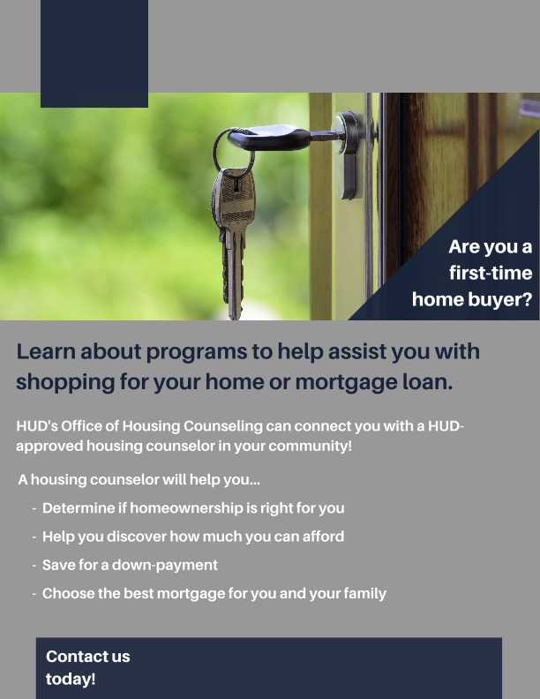
We created a first-time home buyer flyer for your use. You can find it by visiting the Communications 101 Resources page on our website, under the February heading.

Instructions:

- Add your logo:
  - Remove the text box in the top left corner by selecting the box and pressing “Delete.”
  - Add your logo by clicking: Insert >> Pictures >> Picture from File
  - Then, resize your logo accordingly, until the blue box is no longer showing
- Add your contact information:
  - Click “Enter your website here!” and change to your organization’s URL
  - Repeat for “Enter your phone number here!”

You are now ready to print this flyer!

