Sample Posts

These sample posts are ready for your followers – all you have to do is fill in the blanks! You’re free to customize these in any way so that they better reflect the services you offer and specialize in.

HOUSING COUNSELING

- Did you know? In 2015, HUD housing counseling helped prevent 92,000+ foreclosures! We can help you prevent foreclosure, too – visit our website to learn more: [LINK]
- Our HUD-approved housing counselors can help you budget, save, improve your credit score, and buy a home. Want to get started? Visit our website to find out how: [LINK]
- Housing counseling might sound complicated, by what we do is simple: we help you reach your housing goals. Whether you want to buy your first home, need help avoiding foreclosure, or anything in between, we have the tools to help you succeed: [LINK]

PRE-PURCHASE COUNSELING

- Are you a first-time homebuyer? We’re here to help you! Our HUD-approved counselors can offer you FREE advice on the home buying process, help you improve your credit score, and see how much you can afford. Click here to learn more: [LINK]
- Need help saving for a down payment? You may qualify for down payment assistance! Make an appointment to speak to one of our HUD-approved housing counselors today to learn more: [LINK]
- Our pre-purchase housing counseling program is here to help you figure out what you can afford and teach you how to sustain your home for the long-term. Want to learn more? Visit our website! [LINK]

POST-PURCHASE COUNSELING

- Predatory lending can leave you in more debt than you started with. Our post-purchase counselors can help you avoid credit problems and foreclosure – visit our website to learn more: [LINK]
- Homeownership can be tough, and sometimes you fall behind on payments. Don’t wait until you’re under water – speak to our HUD-approved counselors first. We can help put you on the right track to keep your home. Make an appointment by visiting us online: [LINK]
- Do you have needed home repairs, but can’t afford to make them? We may be able to help! Visit our website to learn more about our post-purchase grants and loans: [LINK]

BUDGET AND FINANCIAL LITERACY

- Financial health is just as important as physical health! Our financial literacy classes can help you learn budgeting tools and techniques to manage your money – visit our website to see when our next class is! [LINK]
- Is your credit score lower than you want it to be, but don’t know how to fix it? We can help! Our financial literacy classes will help you understand your credit score and how to improve it. Visit our website to see how you can make an appointment: [LINK]
- Do you want help saving for your future? We’ve got you covered. Join us [DATE] for our upcoming financial literacy class! We’ll go over [LIST COURSE OBJECTIVES]. Click here to register: [LINK]
- [USE WITH GRAPHIC THREE] Financial health and physical health are equally important! We can help you get financially fit – just visit our website or contact us for more information on our Financial Literacy class: [LINK]

Social Media Graphics

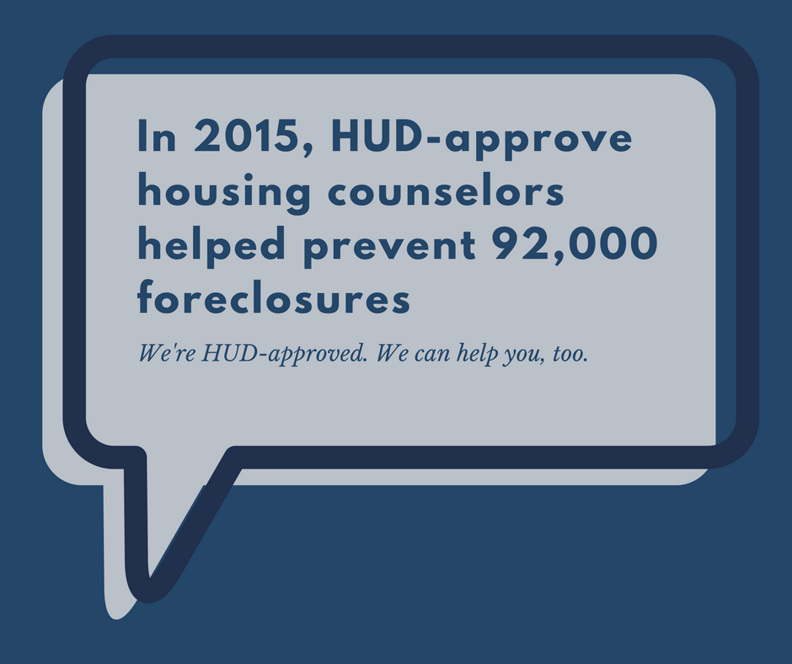
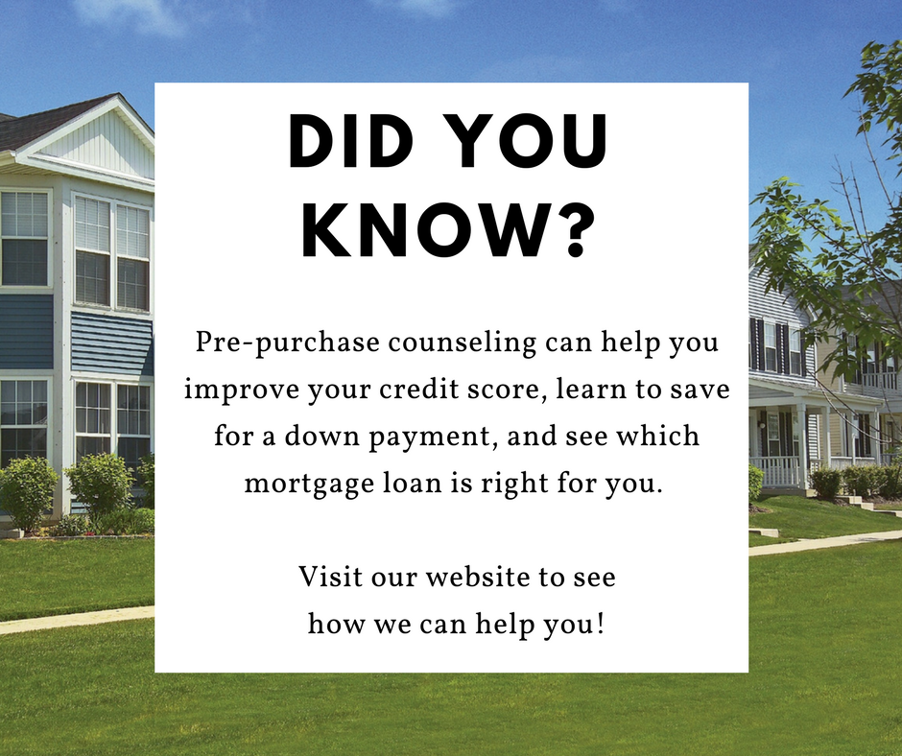
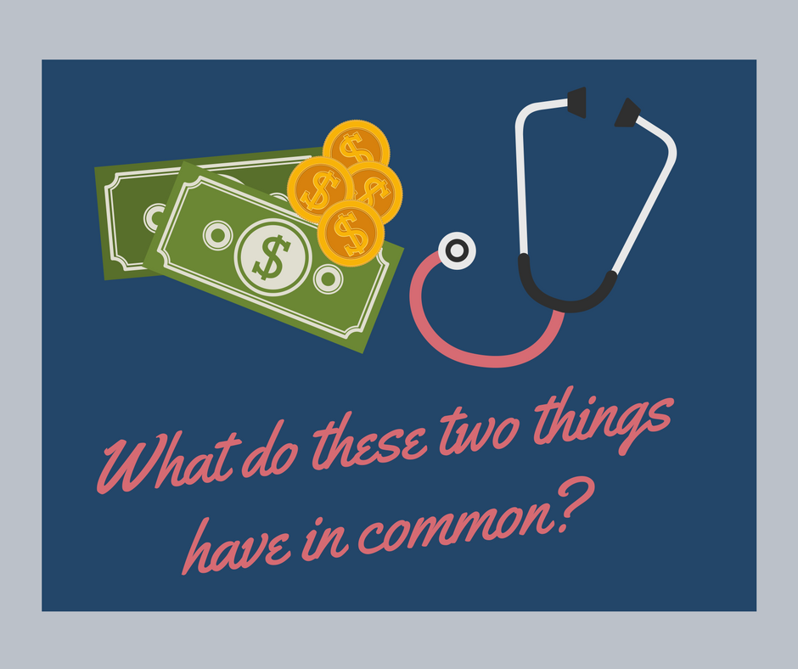
Simply save these pictures to your desk top, and these ready-to-use social media graphics are ready to be uploaded to your social platforms!

