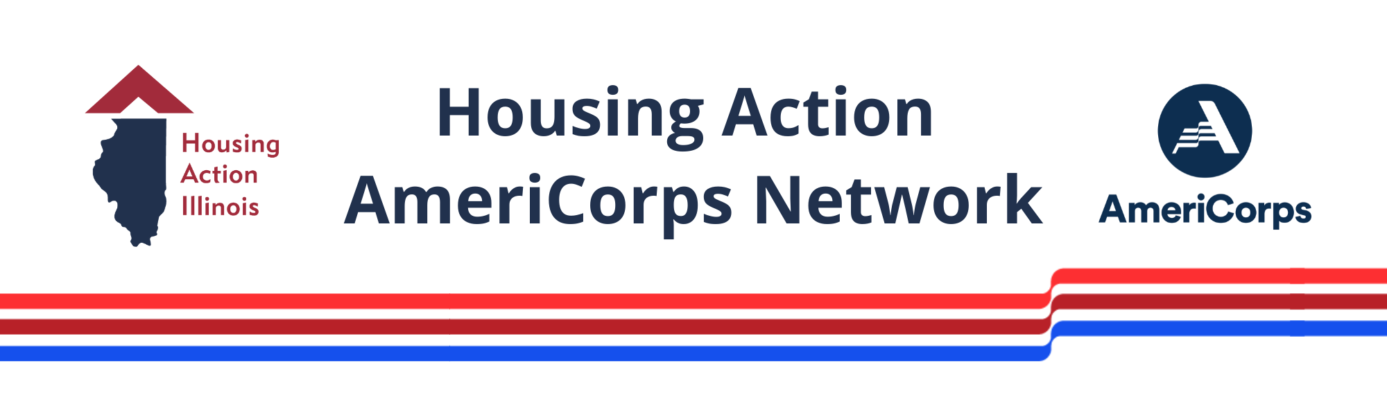

2024-2025 Host Site Application
Community Needs Statement
Answer the following questions to describe how and why your AmeriCorps project will be effective in helping your organization fight poverty in your community. Further resources can be found in the Host Site Application Resources Packet.
1. Using cited evidence, describe the community your AmeriCorps project will serve and the community needs addressed by this work. Include current, relevant community data, such as data from the Census Bureau, local housing authorities & Continuum of Care, and other federal agencies (HUD, DHS, CDC, DOJ, SSA). Cite all sources. 100–300 words

2. Using cited evidence, describe how the approach you are taking in this project will enhance your organization and alleviate poverty in your community.
All projects must indicate how the AmeriCorps member will reduce community poverty, even if the project indirectly impacts poverty by focusing on intersecting issues (such as access to housing, hunger, health care, or education). Incorporate evidence that suggests your approach will be successful, including local experience, recommendations from credible research, or results from a similar, successful program. Cite all sources. 100–300 words

VISTA Assignment Description (VAD)
AmeriCorps Position Title:
Host Organization:

VISTA Assignment Objectives and Member Activities
Goal of the Project (750 characters with spaces):
The Goal Statement defines the overall direction and long-term goals of your AmeriCorps project. It should introduce your organization and mission, identify a community need, describe how the AmeriCorps member will address this need, and state how the project will help break the cycle of poverty. It should be clear what your AmeriCorps member will do, and how this project will help your organization serve your community in new ways.

Objective of the Assignment (1,000 characters with spaces):
Objectives indicate the short-term outcomes and milestones that the AmeriCorps member will achieve to approach their long-term project goals. Objectives should communicate a timeframe for implementation, specify measurable outcomes when appropriate (e.g., develop relationships with 10 organizations), and remain focused on capacity building.
08/26/2024-08/25/2025 - adjust the timeframe for each objective

Member Activities (2,500 characters with spaces):
Member Activities outline the steps and process the AmeriCorps member will follow to complete the assignment objectives. Member Activities should specify measurable outcomes when possible and include any actions that will make the project sustainable for the organization (e.g., create a program manual and train 2 staff).

Objective of the Assignment (1,000 characters with spaces):
08/26/2024-08/25/2025

Member Activities (2,500 characters with spaces):

Objective of the Assignment (1,000 characters with spaces):
08/26/2024-08/25/2025

Member Activities (2,500 characters with spaces):

Objective of the Assignment (1,000 characters with spaces):
08/26/2024-08/25/2025

Member Activities (2,500 characters with spaces):

Objective of the Assignment (1,000 characters with spaces):
08/26/2024-08/25/2025

Member Activities (2,500 characters with spaces):

Leave this objective as-is—we include it for all AmeriCorps members!
Objective of the Assignment (1,000 characters with spaces): 08/26/2024-08/25/2025
Develop critical interpersonal and technical skills of nonprofit and public sector professionals to become a competitive candidate for post-service plans, such as employment, education, or continued national service.
Member Activities (2,500 characters with spaces):
- Learn about reporting requirements and project expectations by attending virtual training with Housing Action Illinois, meetings with site supervisors, and check-in calls with AmeriCorps Leaders and Housing Action staff.
- Thoroughly complete bi-weekly timesheets, monthly reports, and semi-annual narrative reports.
- Develop strong tracking tools that align with the outcomes of the VAD and performance plan to accurately track the beneficiaries of the capacity building accomplishments during the term of service.
- Ensure that AmeriCorps branding is included on print and digital materials created during the term of service, as well as the host site website.
- Raise awareness of the host organization, Housing Action Illinois, and AmeriCorps by elevating stories of impact. Pay attention to and share events, meetings, and interactions with community stakeholders (including project partners, funders, local elected officials, and media outlets).
- Attend mandatory in-person and virtual In-Service Trainings offered throughout the term of service and coordinated by Housing Action Illinois.
- Engage with the cohort of Housing Action AmeriCorps members and the broad, national network of AmeriCorps members through social and professional development events, peer-learning, and reading groups.

